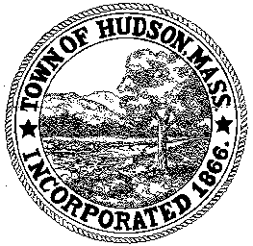

CONSERVATION COMMISSION
78 Main Street, Hudson, MA 01749
(978) 562-2020

Leif Longtine, Chairman David Esteves, Vice Chairman Paul Byrnes, Member

Terrence Joyce, Member Joseph Rodrigues, Member W. Minot Wood, Member

Meeting Minutes
March 21, 2013

- Preliminaries
  - Meeting was called to order at 7:00 PM
  - Roll Call: Leif Longtine, Paul Byrne, Joe Rodrigues and Minot Wood

2.0 New Business
2.1 RDA 440 continued
Applicant: Hudson DPW
Location: 25 Washington Street
Project Description: removal of trees and fence and installation of a new
8’ fence.
Paul motioned to close the public hearing and issue a negative determination with the provision that jersey barriers be placed 5’ from the fence along the full length of fence with a 4’ opening at the service gate. Signs shall be placed on the fence stating, “No snow storage”. Motion was seconded by Minot and carried 4-0

2.2 DEP 190-0570
Applicant: John and Kathy Adams
Location: 81 Hunter Avenue
Project Description: an addition to an existing house with a patio extension
Minot motioned to close the public hearing and issue an Order of Conditions. Motion was seconded by Paul and carried 4-0.

2.3 MA DEP 190-0561
Superseding Order of Conditions - noted

2.4 Minutes – January 3, 2013 – tabled until 4/4/13
2.5 Minutes: March 14, 2013 – tabled until 4/4/13

3.0 Meeting was adjourned at 7:15PM

